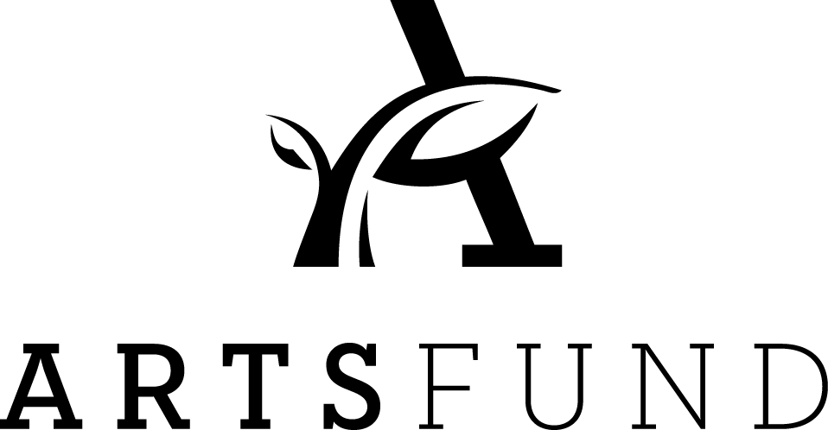
Campaign 2017
In-Kind Pledge Form
Company:
Contact Name:
Address:
City: |  | State: |  | Zip:
 |  | Phone: |  | Email

I/We are pleased to make a Campaign 2017 in-kind contribution valued at $___________ to the ArtsFund Associates Program

Please provide a description of your in-kind contribution:

_______________________________________________________________________

_______________________________________________________________________

_______________________________________________________________________

_______________________________________________________________________

Thank you!

